**C-Power2&3 Serials Manual**

1. **the view of the control card：**

10PIN Extended Interface

D4 Running status indicator

3P Temperature interface

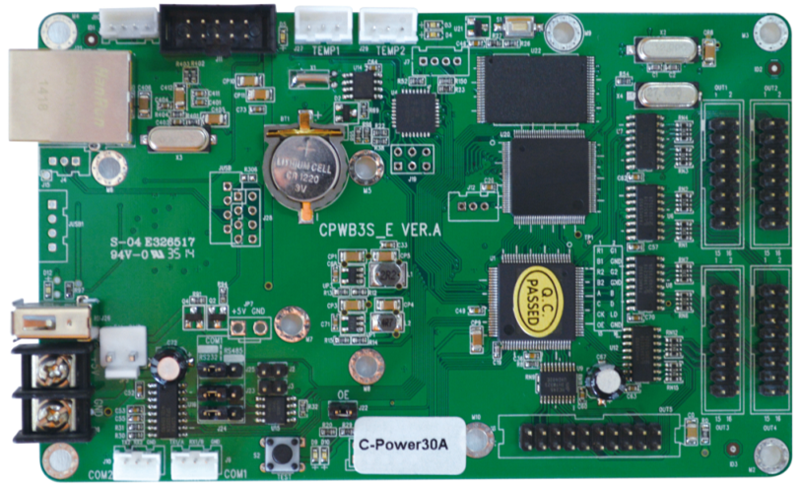

Power interface

USB interface

Network interface

D5 Indicator light of the screen

OUT1~OUT4 HUB75output interface

20P interface, connect an external HUB

RS485 Terminal matching resistance

COM1

COM2

COM1port choose RS232or 485 through the jumper

**二、Interface And Indicator**

## 1、power interface

【**JP5/JP6】：the board power interface**

* ＋5V direct current supply interface

working current**：**300～600mA

work environment**：**up to GB/T 2423.25 GB/T 2423.26

* Reverse connection**：**It can be protective when connect the wire inversely
* Soft start：it won’t impact the board when power on
* Overvoltage protection**：**when the input power voltage is more than 6V,then the board will power off automatically
* Low-voltage protection**：**when the input power voltage is lee than 3.5V,then the board will power off automatically
* Short-circuit self-recovery**：**when the output interface is 5V short-circuit,the self-recovery safety of the card will shut off. And when the short-circuits relieves the control card to be able the rehabilitation

## 2、display interface

【OUT1~OUT4】：standard HUB75 output

【OUT5】：20P extension interface , it can connect an external HUB(such as HUB08 HUB12)

## 3、extended interface

**【J11】I2C attachment interface**

function：provide standard I2C , external function attachment

**【J11】standard 10PIN extended interface**

Pin definitions：

|  |  |  |  |
| --- | --- | --- | --- |
| **Signal name** | **Pin number** | **Pin number** | **Signal name** |
| Analog signal input pin | 1 | 2 | +5Vpower output |
| Multifunction digital signal 1 | 3 | 4 | +5Vpower output |
| Multifunction digital signal 2 | 5 | 6 | GND |
| Multifunction digital signal 3 | 7 | 8 | GND |
| Power switch control | 9 | 10 | GND |

Function description：

|  |  |  |
| --- | --- | --- |
| **Pin number** | **Signal name** | **Function description** |
| 1 | Analog signal input pin | Monitor kinds of external analog signal input，standard attachment is light sensor |
| 3 | Multifunction digital signal 1 | Input or output,standard attachment is remote control input |
| 5 | Multifunction digital signal 2 | Input or output, reserved pin |
| 7 | Multifunction digital signal 3 | Input or output |
| 9 | Power switch control | Drive external circuit directly, control the switch of the display. It needs to connect relay, D5 indicates the status on-off of the display |
| 2、4 | +5Vpower output | provide power to the external attachment |
| 6、8、10 | GND | the GND which connects with the external attachment |

## 

## 4、communication interface

### **(1)Network interface：**

The card supports network communication, standard TCP/IP internet access. It can connect with the computer internet access,or via the switches LAN or the internet

【connecting with network cable】：via standard network cable（international standard EIA/TIA568A/B）connecting with computer. Or via the switches LAN or the internet

|  |  |
| --- | --- |
| number | color |
| 1 | Orange and white |
| 2 | Orange |
| 3 | Green and white |
| 4 | Blue |
| 5 | Blue and white |
| 6 | Green |
| 7 | Brown and white |
| 8 | Brown |

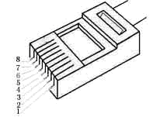

1. Figure1 568B network cable

### 

### **(2)USB flash disk**

### You can update the program via the USB flash disk, the standard is USB interface

### **(3)Serial port**

C-Power2&3 serials has two serial ports：

**COM1**（J9）：RS232/RS485 option , via the J23/J24/J25 jumper

**COM2**（J10）：RS232（reserved）

【COM1 communication option】

RS232 mode : Short out the PIN1 and PIN2 with the jumper of J23、J24、J25

RS485 mode : Short out the PIN2 and PIN3 with the jumper of J23、J24、J25

【terminal matching resistance of the RS485 mode】

In RS485 mode you can connect more than one control card .If necessary , connecting the terminal matching resistance in the last control card：short out the J2 and J3 of the last control card with the jumper

【serial port line description】

1. COM1 of the card——J9

|  |  |  |  |
| --- | --- | --- | --- |
|  | Signal name | **J9 pin number** | **COM pin number of computer（DB9 interface）** |
| 1 | TX1 | **1** | **2** |
| 2 | RX1 | **2** | **3** |
| 3 | GND | **3** | **5** |

1. Table1 COM1 select RS232 mode

|  |  |  |  |
| --- | --- | --- | --- |
|  | Signal number | **J9 pin number** | **485transverter interface** |
| 1 | A | **1** | **485+** |
| 2 | B | **2** | **485-** |
| 3 | GND | **3** | **GND** |

1. Table2 COM1 select RS485 mode

### **Indicator light**

### **【D4】：**running indicator，if the indicator light is uniform flicker that means the control card is running well

### **【D5】：**indicator light of the power switch of the display. When the power switch of J11 controls the PIN9 to control the on-off of the display, the indicator D5 indicates the status on-off of the display.

### **三、dimensional drawing**

### 