C-Power5200、4200 controller can not communicate with network

1、open the software LedCenter, and click “Tools → Find device → Search Network” ,set the right IP and then click “Start search” .If you can find the controller, it says that the controller is connected with the computer well.(the default IP address of the controller is 192.168.1.222)
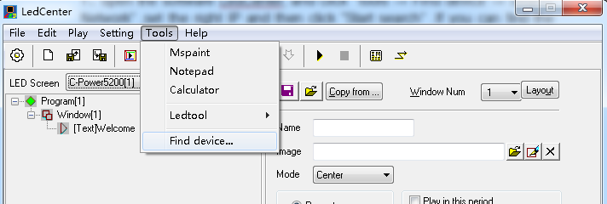

Start search
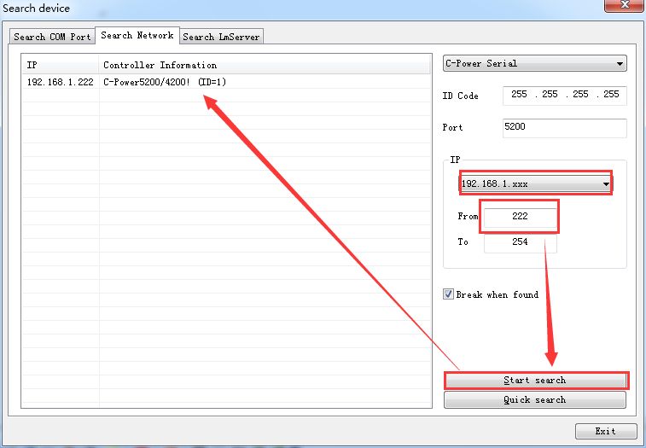

Quick search
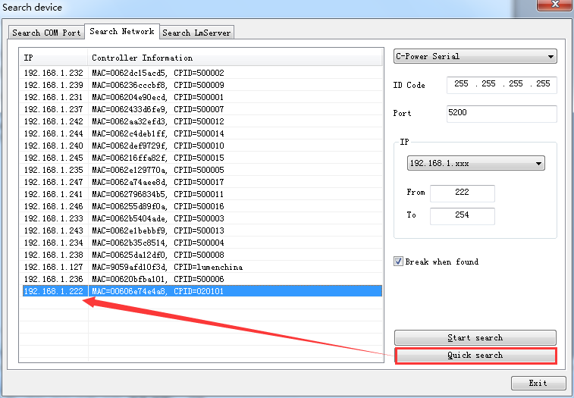

IF you can’t find the controller , it may be caused by the following reasons:

⑴controller is directly connected with the computer with network cable

①whether the controller is in the same network segment as the computer IP address?(the computer can’t set to obtain an IP address automatically )
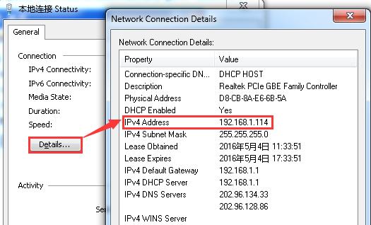
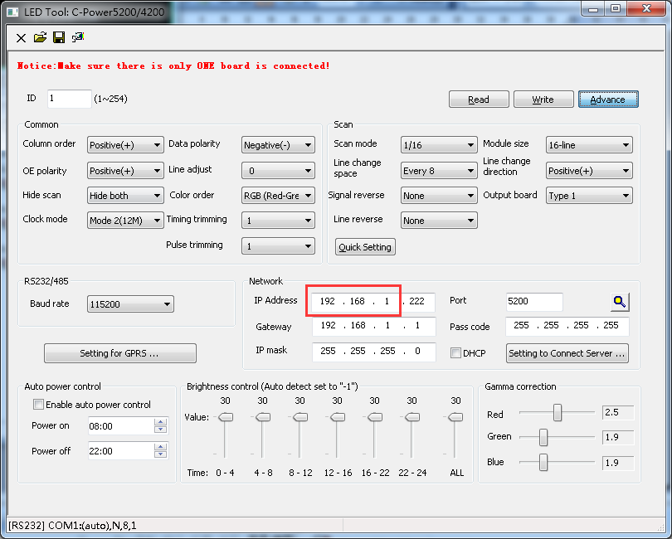
Note: you can enter this interface like this :“Tools→ Ledtool→C-Power5200/4200”

② If they are not in the same network segment, then open orderly “local connectivity” →”Properties” →”Internet Protocol Version 4(TCP/IPv4)”,and then modify the IP address .
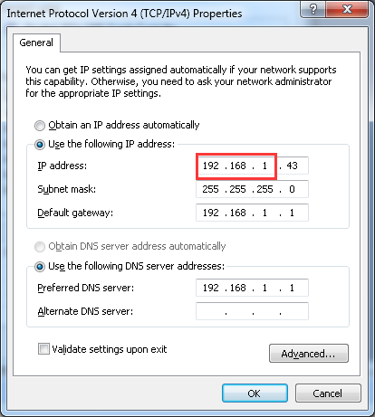

If it is not convenient to modify the computer IP address ,you can also modify the IP of the controller and then click “Write” to save the IP address .The controller should be re-up electricity after modifying the IP address.
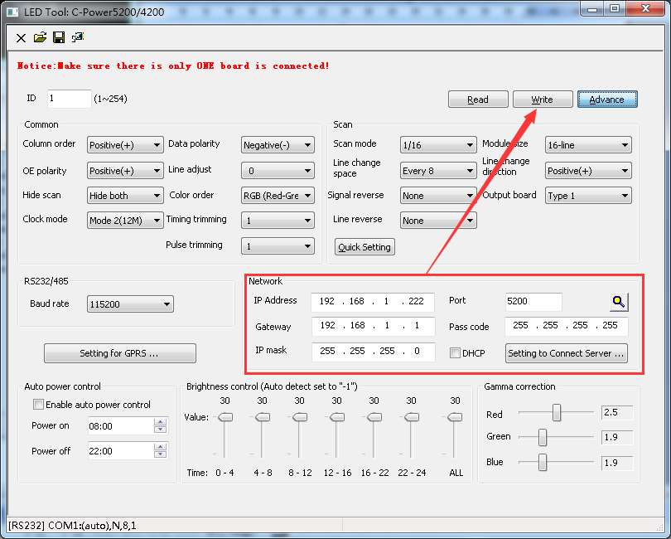

⑵the controller is connected with the computer in the same local area network
① the computer can set to “obtain an IP address automatically ”,but the controller and the computer should be in the same network segment. Open the “local connectivity” in the bottom-right of the screen, and then click the “Details” to check the IP address.
② If they are not in the same network segment ,then modify the IP of the controller(If you want to modify the IP of the router ,please call the LUMEN ENGINEER)

How to modify the IP of the controller ?

Choose the right communication “Network” →”Read” →”Advance” (enter password
26888)→”Network”(set the right IP address) →”Write”(re-up electricity after “Write”)
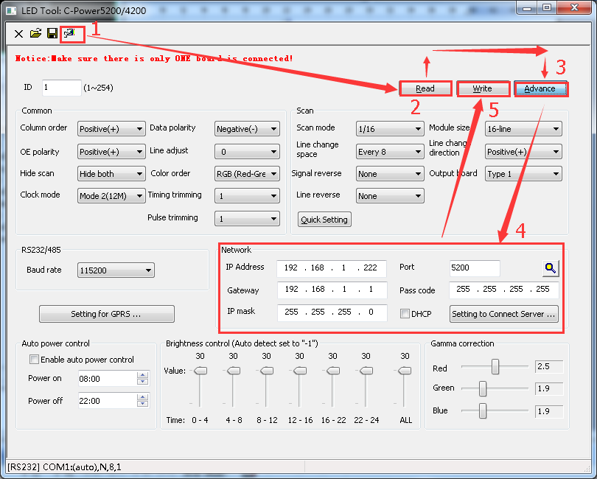

- You can find the controller in the “Find device”, but can not “read”?
Open the software LedCenter ,click “Tools → Ledtool → C-Power5200/4200 →communication→ write the right IP →OK →Read”. If it is “Successful” ,now the controller can communicate well.
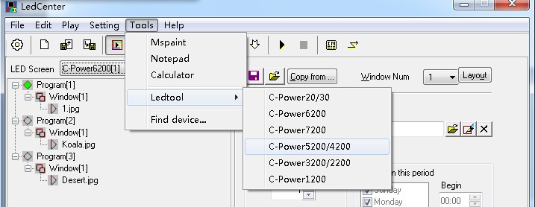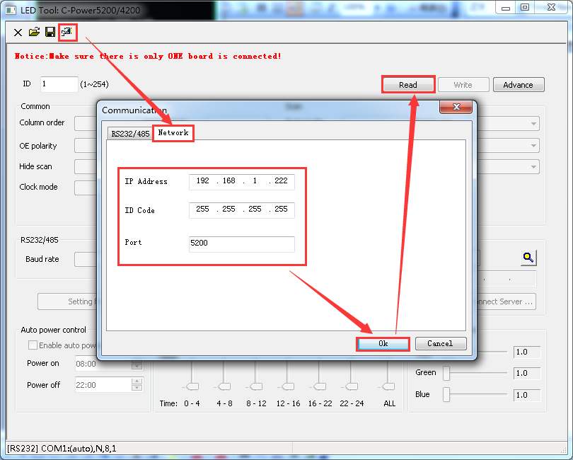

3、It can “Read” successfully ,but it can not send the program?
Click “Setting→Advance→Define Led screen→new or edit”(the password is 16888)；Choose the type of the controller；select the right Width and Height(the Width and Height is the width and height of the Led screen).Select the Communication Type, click “OK” and then you can send the program.
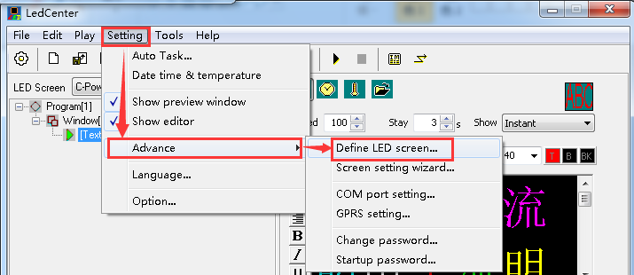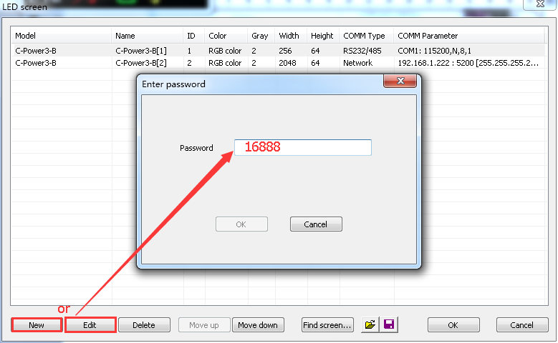
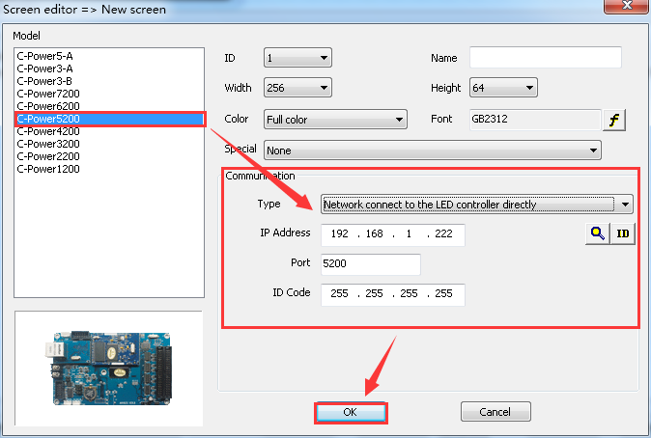

4、Whether the internet access is in the normal operation?
When the controller is in the normal operation , the green light of the internet access keeps on .Otherwise please check whether the internet access is poor
contact or the cable is bad.
